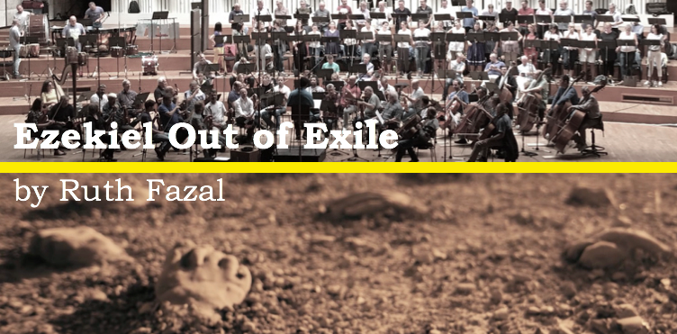

“Creating an impression on your soul”

As you may know, Ruth has recently finished writing and recording a new musical work, based on Ezekiel’s vision of the Valley of Dry Bones.
“Ezekiel Out of Exile” has now been combined with extraordinary videography, and is available for screening. Through this unique combination of music and imagery, the audience is drawn into Ezekiel’s vision, and God’s promises and purpose for Israel are revealed as this film takes us on a journey from exile to redemption, bringing Ezekiel’s remarkable vision into the present day.

‘Ezekiel Out of Exile’ is now available to you for a screening, to provide a unique evening for your congregation or community.

Create a special event!
HOST A SCREENING OF
“EZEKIEL OUT OF EXILE”
Cost: £299
How it Works: You choose the time, and we provide the link for you to screen the film. Immediately following the screening, Ruth will be available for a live video call with your audience, and would love to share with you a little about the journey of writing “Ezekiel Out of Exile” and to answer any questions you may have.

Please let us know by return email if you would like to host a screening. ezekieloutofexile@gmail.com

